Michael Smith

CSE 570

Final Exam

10 June 2018

1. Define a complex number as an integer or floating point number, followed by a lower-case i followed by another integer or floating point number.Allow either the first or the second number, or both, to have an optional - sign.Floating point numbers must begin with a non-zero digit or "0.", and there must beat least one digit to the right of the decimal point. The following are complex numbers: -45i3.2 , 45.001i-5.5, 0.003i315, 0.0i0.0The following are not:+33i14.7 , -i33.5 , 00.01i45Write a regular expression to represent such a number. Draw a graph of a DFA that accepts the language defined by your expression. You may use LEX syntax forregular expressions.

Solution:

The RE for the LEX syntax is :

[-]?((([1-9]+)([0-9]*)|[0])(\.[0-9]+)?) [i] [-]?((([1-9]+)([0-9]*)|[0])(\.[0-9]+)?)

The ? Operator represents optional element of an expression. The + and * are for repetition patterns. While the ([1-9]([0-9]*) is the part of the number before the decimal point. And the (\.[0-9]+) is the decimal poing followed by digits. For example .23 or .0023 depending on the repetitions.

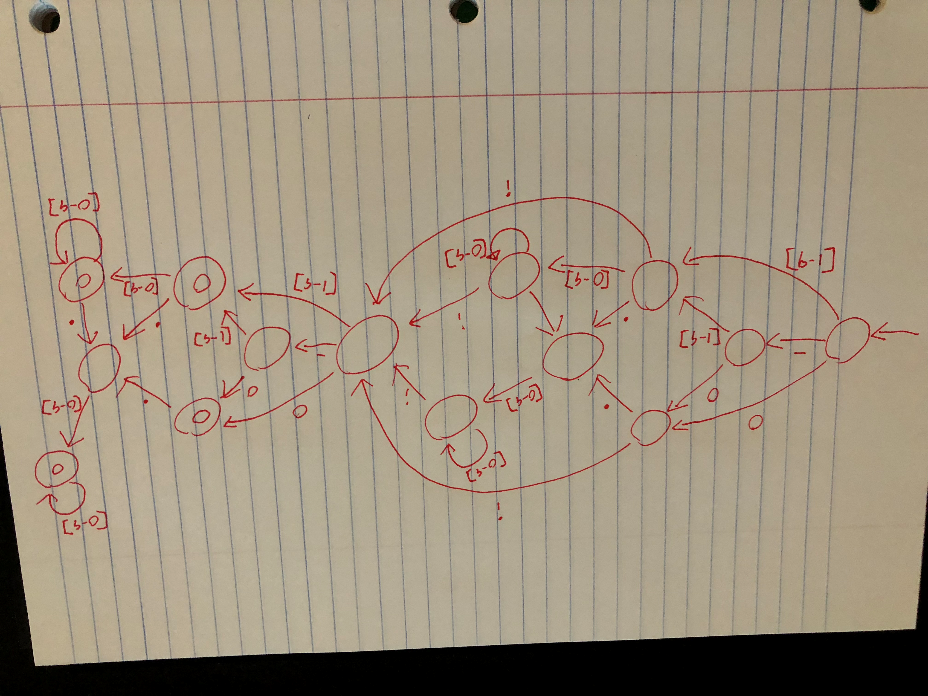

1. Consider S -> aSbS | bSaS | e Show this is ambiguous. Describe the language generated by this grammar.

Solution:

A grammar is ambiguous if it gives more than one rightmost cradle. Or more than one left most cradle. As well as if there is more then one possible parse tree from a string.

For example the string abab has 2 possible parse trees

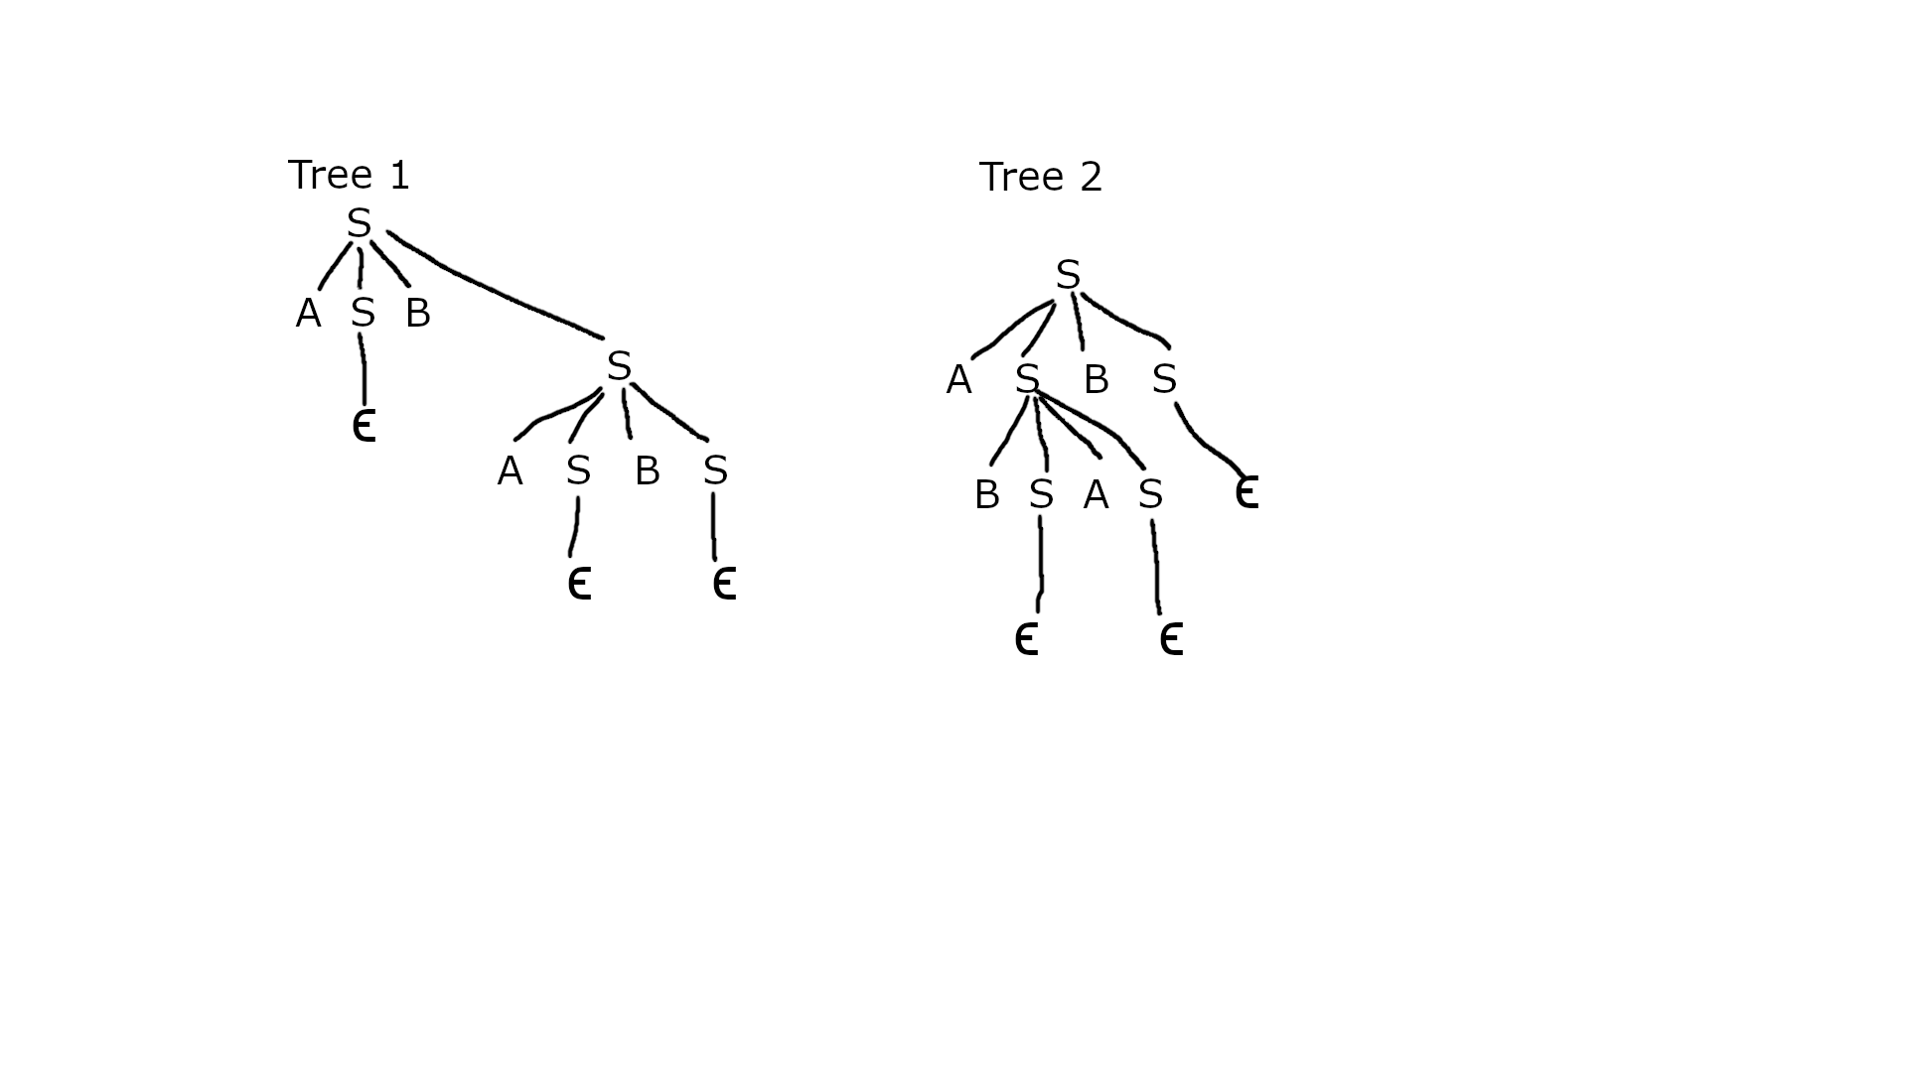

Therefore the given grammar is ambiguous.

1. Consider the following grammar (describing type statements): S -> TL T -> i | r L -> L,i | iFind FIRST, FOLLOW and LR(0) sets for this grammar.Is the grammar LR(0)? Is it SLR?

Solution:

First : Follow

S -> TL{i,r} : {$}

T -> i|r {i,r} : {v}

L -> L,v|v {v} : {$ comma}

LR(0) items are

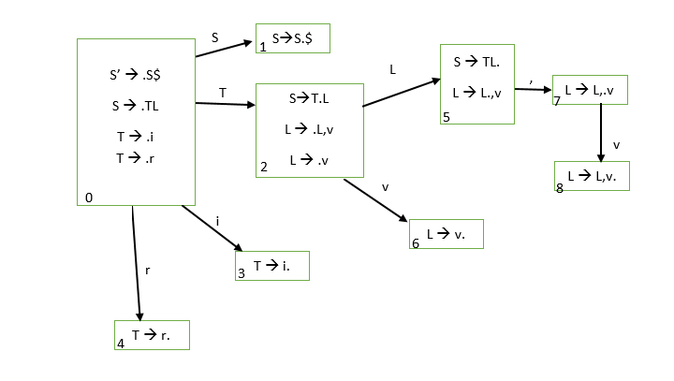

LR(0) parse table:

R1: S -> TL R2: T -> i R3:T -> j R4: T -> v R5: T -> T,v

|  |  |  |  |  |  |  |  |  |
| --- | --- | --- | --- | --- | --- | --- | --- | --- |
| L | i | r | v | , | $ | S | T | L |
| 0 | S3 | S4 |  |  |  | G1 | G2 |  |
| 1 |  |  |  |  | Accept |  |  |  |
| 2 |  |  | S6 |  |  |  |  | G5 |
| 3 | R2 | R2 | R2 | R2 | R2 |  |  |  |
| 4 | R3 | R3 | R3 | R3 | R3 |  |  |  |
| 5 | R1 | R1 | R1 | R1/S7 | R1 |  |  |  |
| 6 | R4 | R4 | R4 | R4 | R4 |  |  |  |
| 7 |  |  | S8 |  |  |  |  |  |
| 8 | R5 | R5 | R5 | R5 | R5 |  |  |  |

There is a collision, so the grammar is not LR 0

SLR parsing table:

|  |  |  |  |  |  |  |  |  |
| --- | --- | --- | --- | --- | --- | --- | --- | --- |
| L | i | r | v | , | $ | S | T | L |
| 0 | S3 | S4 |  |  |  | G1 | G2 |  |
| 1 |  |  |  |  | Accept |  |  |  |
| 2 |  |  | S6 |  |  |  |  | G5 |
| 3 |  |  | R2 |  |  |  |  |  |
| 4 |  |  | R3 |  |  |  |  |  |
| 5 |  |  |  | S7 | R1 |  |  |  |
| 6 |  |  |  | R4 | R4 |  |  |  |
| 7 |  |  | S8 |  |  |  |  |  |
| 8 |  |  |  | R5 | R5 |  |  |  |

There is no collision, therefore the grammar is SLR.

1. The following grammar applies + and * operators to integer and real constants. The result of adding two integers is type integer, otherwise the result is type real. A number (T) with a decimal point is real, otherwise is integer.E-> E+T | TT-> T*F | FF-> num.num | numWrite a syntax directed definition for this grammar to determine the type of each subexpression. Write semantic actions to output 3-address cide. Use a function INT2REAL, applied to integer values to ensure that both operands in a postfix expression have the same type.

Solution:

|  |  |
| --- | --- |
| Production | Semantic Rule |
| X1 -> E | X1 vlaue = E. value |
| X1 -> E' | X1 value = E'. Value |
| E -> E + T | ADDI E E T |
| E -> T | E. value = T. value |
| T -> T * F | MULI T T F |
| T -> F | T. value = F. value |
| F -> num | F. value = num |
| E' -> E' + T' | ADDR E E T |
| E' -> T' | E'. Value = T'. value |
| T' -> T' * F' | MULR T T F' |
| T' -> F' | T'. Value = F'.value |
| T' -> T' * F | INT2RL F F ;  ADDR T'T'F |
| T' -> F | INT2RL F F;  T'.value = F.value |
| F' -> num.num | F'.value = num.num |

There is two conditions in the provided productions: E and E'

E:

It included the variables E, T, and F. Implementations:

E -> E + T | T

T -> T * F | F

F -> num

E':

The second part starts to have operations for the real numbers such as:

E' -> E' + T' | T'

T' -> T' * F' | F' | T'*F | F

F' -> num.num

And the productions T' -> T' *F AND T' -> F are converting numbers from ints to real numbers

1. Give a rightmost derivation of the string (x+a)*x using:S=> EE=> E+T | TT=> T*F | FF=> i | (E)The lexical analyzer returns a token i==identifier for variables 'x' and 'a'.Display the parse tree, the syntax tree, and the expression DAG.EXTRA credit: The algorithm for DOM in the text is based on data flow analysis,but it is often desirable to find the DOM tree from the control flow graphwithout the need to do data flow. Create an algorithm that finds the DOMtree based on breadh-first or depth-first search.

Solution:

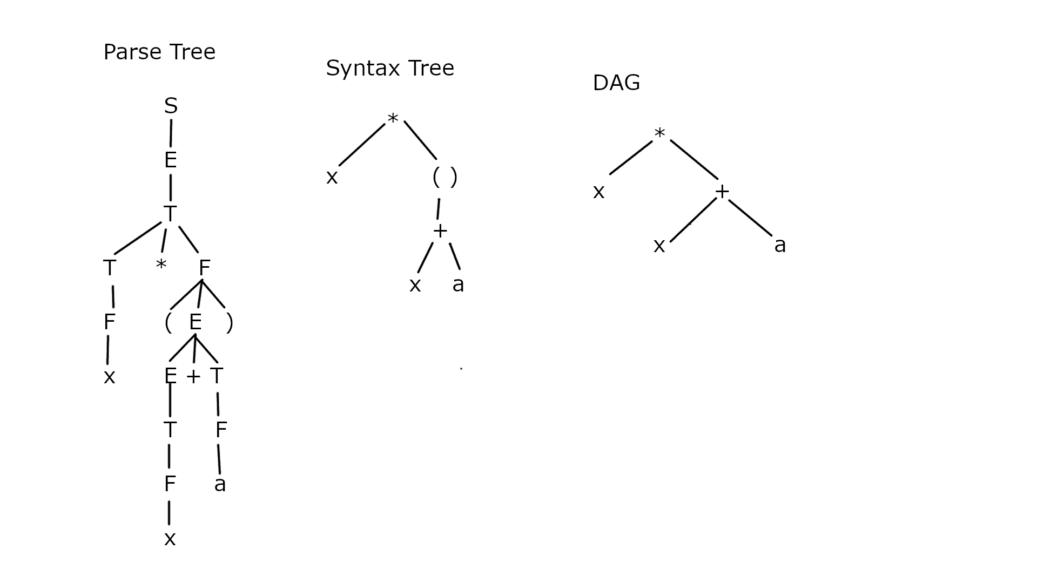

Here is the parse tree (left), the syntax tree (center) and the DAG tree (right).